**MGoS Pre HLPF Event-9th July (UN Church Center- 9-1500 hrs)**

UN DESA Division for Sustainable Development and the MGoS HLPF Coordination Mechanism organized a **pre-HLPF preparatory meeting**, on ***Sunday, 9 July 2017, from 9:00 to 15:00*** at the Church Center (777 UN Plaza, New York), second floor.  The full-day preparatory meeting was promoted understanding of the HLPF, the 2030 Agenda for Sustainable Development, the opportunities and procedures for engagement throughout the HLPF, and peer-to-peer learning sessions and exchanges among representatives of major groups and other stakeholders.  Additionally, it was also a good moment to network, become familiar with one another, and share experiences in implementation efforts, as well as for identifying common ground and different perspectives.

The meeting deliberated the proposed outputs of HLPF 2017:

1. Austria and Jamaica are going to be part of Ministerial negotiations
2. Summary of the president of the ECOSOC, seek to capture the points and recommendations
3. Second SDG progress report (UN statistics decisions), will be introduced to the HLPF

140 side events

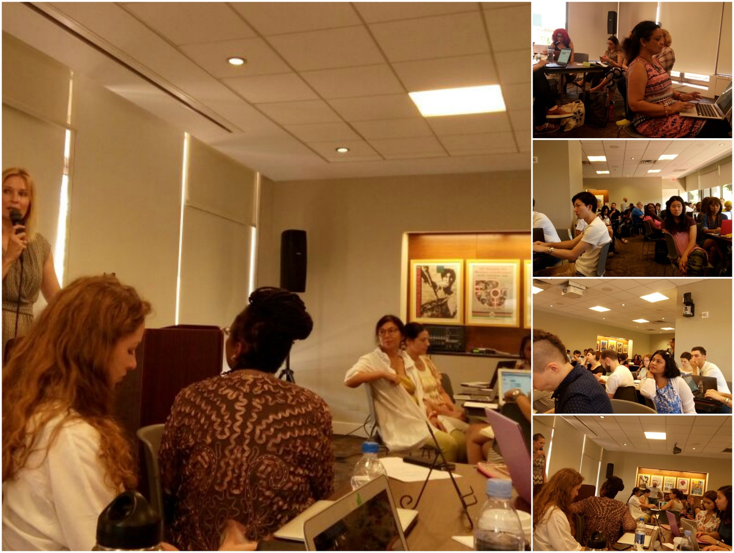

The participants disused VNR , shrinking civil society spaces (paragraph 89), MGoS engagement, science policy interface and communication strategies in various groups and deliberated;

1. On ways improve the method of consultation. The current method is not efficient in terms of participation of CSO representatives, which needs to be improves, for better credibility, transparency
2. We need a better coordination mechanism, to promote participation of CSOs at national level, (the national level coordination is not efficient, in terms of ensuring all group representation in most of the countries), for example, VNR- many participants said, they did not know the purpose, or the government process, , on how to engage
3. Lack of official channel for CSO to participate in VNR process, formalize, institutional setting so CSO can participate
4. Need of creating more capacity at local level
5. We still need local of efforts at national level to participate in VNR. The UN system, and other cooperation agency must also be involving to allocate resource on skill development
6. parallel reporting model- whether or not we want to have a parallel reporting, some call it shadow report, if Geneva model can be represented in HLPF. Time for us to start thinking on better parallel reporting process.
7. relevance of multi lateral dimensions, how to enhance the structure of discussion, relevance of UN system
8. balance between formal and informal opportunities
9. how-to be engaged in formal VNR sessions
10. how to improve with better coordination mechanism ‘how to value the informal way of engagements
11. in touch with social network
12. the importance of govt. and citizenship, how to enhances of ground level people, how to make the connection and facilitating the space
13. how to channelize is strategy, opportunity and challenge
14. to use better online platform, parallel report, webinars, how to increase Capacities of peers
15. three dimension of SDG is also a challenge and we keep on leading to learn from each other
16. collective work, not enough through two weeks but whole year process is important to remain in touch, to improve strategy in next years
17. Better communication strategies, Twitter #HLPF, Facebook apart from daily reporting